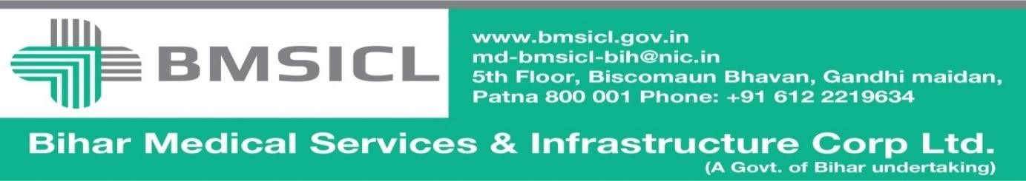

Corrigendum-II
Bihar Medical Services and Infrastructure Corporation Limited (BMSICL) had invited E-Bids from the interested parties for Tender for the supply of Medical Equipment for different Govt. Medical Colleges and Hospitals of Bihar vide Notice Inviting Tender No.-BMSICL/2017-18/ME-068. Detailed tender document containing eligibility criteria, selection mechanism, other terms and conditions are available on the website www.eproc.bihar.gov.in. and www.bmsicl.gov.in . In order to give sufficient opportunity to bidders and to ensure wider participation, the tender schedule is being revised as follows:-

Amended Tender Schedule
Tender Reference No. | BMSICL/2017-18/ME-068
Date and time for downloading of bid document | Up to 18th December 2017 till 15:00 Hrs.
Last date and time of submission of online bids | 20th December 2017 till 17:00 Hrs.
Last date and time for submission of original documents of EMD and Document Fee | 22nd December 2017 until 13:00 Hrs.
Date, Time and Place of opening of Technical Bid | 22nd December 2017 (at 15:00 Hrs.) on the website of www.eproc.bihar.gov.in in the office of BMSICL

Sd/-
GM (Procurement)

