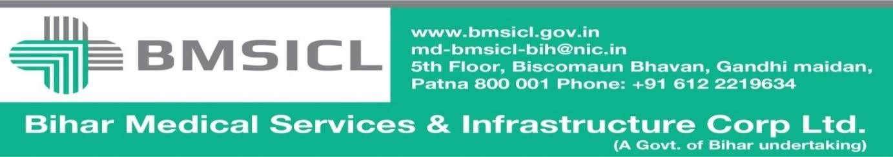

Corrigendum-2

Bihar Medical Services and Infrastructure Corporation Limited (BMSICL) had invited E-Bids from the interested parties for Tender for ''Installation and Running of CT SCAN AND MRI MACHINE UNDER PPP MODE'', vide Notice Inviting Tender No.-BMSICL/2016-17/ME-045. Detailed tender document containing eligibility criteria, selection mechanism, other terms and conditions as amended by corrigendum are available on the website www.eproc.bihar.gov.in. In continuation and further clarification of point no. 6 of Annexure- I of that corrigendum dated 24.02.2017, it is further clarified that presence of a radiologist at every location is not compulsory as reporting through tele-radiology may be allowed. However in case of disruption of internet connectivity the service provider shall ensure timely delivery of reports as per the conditions laid down in the bid document. The tender schedule is, therefore, being revised as follows:-

Tender Reference No. | BMSICL/2016-17/ME-045
Date and time for downloading of bid document | up to 27/03/2017 till 17:00 Hrs.
Last date and time of submission of online bids | 03.04.2017 till 17:00 Hrs.
Last date and time for submission of original documents of EMD and Document Fee | 06.04.2017 till 14:00 Hrs.
Date, Time and Place of opening of Technical Bid | 06.04.2017(at 15:00 Hrs.) on the website of www.eproc.bihar.gov.inin the office of BMSICL
Date and time of opening of financial Bids | To be announced later on www.eproc.bihar.gov.in

Sd/-
GM (Procurement)
BMSICL

