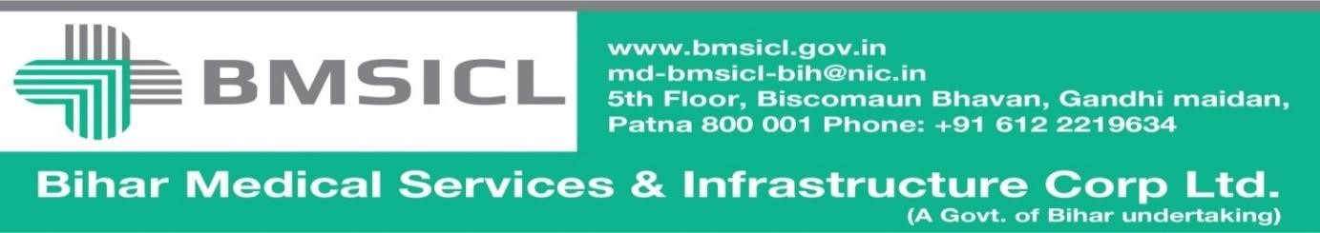

Corrigendum-1

Bihar Medical Services and Infrastructure Corporation Limited (BMSICL) had invited E-Bids from the interested parties for Tender for the supply of Blood Bank Equipment for different Govt. Medical Colleges and Hospitals of Bihar vide Notice Inviting Tender No.-BMSICL/2016-17/ME-046. Detailed tender document containing eligibility criteria, selection mechanism, other terms and conditions are available on the website www.eproc.bihar.gov.in. In order to facilitate the downloading of amendments as per Pre-bid meeting held on 01/03/2017, the tender scheduled is being revised as follows:-
Tender Reference No. | BMSICL/2016-17/ME-046
Date and time for downloading of bid document | Up to 23th March 2017 till 15:00 Hrs.
Last date and time of submission of online bids | 30th March 2017upto 17:00 Hrs.
Last date and time for submission of original documents of EMD and Document Fee | 2nd April 2017 until 14:00 Hrs.
Date, Time and Place of opening of Technical Bid | 2nd April 2017 (at 15:00 Hrs.) on the website of www.eproc.bihar.gov.inin the office of BMSICL
Date and time of opening of financial Bids | To be announced later on www.eproc.bihar.gov.in

Note:- Please refer to the Annexure- I of this corrigendum before submission of bid.
Sd/-
GM (Procurement)
BMSICL

