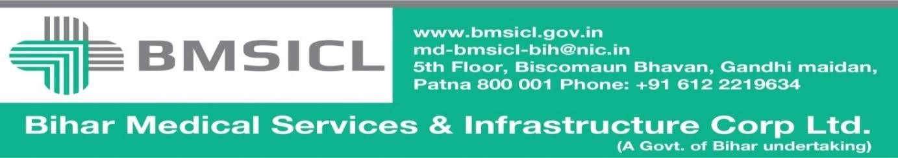

Corrigendum-1

Bihar Medical Services and Infrastructure Corporation Limited (BMSICL) had invited E-Bids from the interested parties for Tender for the supply of Medical Equipment for Bihar Drug Control Laboratory, Patna of Bihar vide Notice Inviting Tender No.-BMSICL/2017-18/ME-064. In order to facilitate the downloading of amendments as per Pre-bid meeting (Annexure-I) held on 18/09/2017, the tender scheduled is being revised as follows:-
Tender Reference No. | BMSICL/2017-18/ME-064
Date and time for downloading of bid document | Upto 17th October 2017 till 17:00 Hrs.
Last date and time of submission of online bids | 23rd October 2017upto 17:00 Hrs.
Last date and time for submission of original documents of EMD and Document Fee | 25th October 2017 until 14:00 Hrs.
Date, Time and Place of opening of Technical Bid | 25th October 2017(at 15:00 Hrs.) on the website of www.eproc.bihar.gov.inin the office of BMSICL
Date and time of opening of financial Bids | To be announced later on www.eproc.bihar.gov.in

Sd/-
GM (Procurement)
BMSICL

