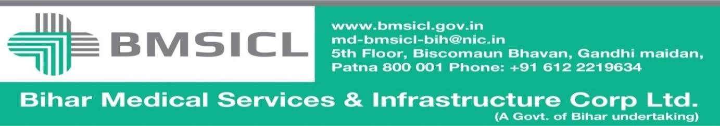

Corrigendum-1

Bihar Medical Services and Infrastructure Corporation Limited (BMSICL) had invited E-Bids from the interested parties for development, operations and maintenance of MRI Machine in four medical college hospitals of Bihar on PPP mode vide Notice Inviting Tender No.-BMSICL/2017-18/ME-072, In order to give sufficient opportunity to bidders and to ensure wider participation. The tender scheduled is being revised as follows:-
Tender Reference No. | BMSICL/2017-18/ME-072
Date and time for downloading of bid document | Up to 10th January 2018 till 15:00 Hrs.
Last date and time of submission of online bids | 12th January 2018 upto 17:00 Hrs.
Last date and time for submission of original documents of EMD and Document Fee | 15th January 2018 14:00 Hrs.
Date, Time and Place of opening of Technical Bid | 15th January 2018 (at 15:00 Hrs.) on the website of www.eproc.bihar.gov.inin the office of BMSICL
Date and time of opening of financial Bids | To be announced later on www.eproc.bihar.gov.in

Sd/-
GM (Procurement)
BMSICL

