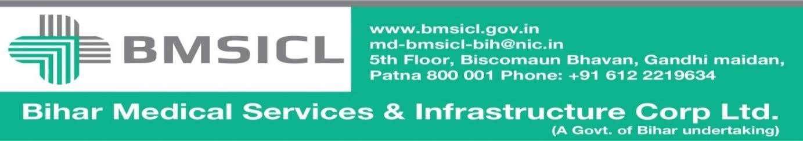

TENDER NOTICE

(Notice Inviting E-Bids)
Tender for the supply of Medical Equipment for different Govt. Medical Colleges and Hospitals of Bihar
Notice Inviting Tender Ref No.- BMSICL/2016-17/ME-053 Dated: January 2017

(Only through E- Tender on website:-www.eproc.bihar.gov.in)
The Bihar Medical Services and Infrastructure Corporation Limited, Patna invites e-bids from interested parties for SUPPLY, TESTING, DEMONSTRATION, INSTALLATION & COMMISSIONING of Medical Equipment for different Govt. Medical College and Hospital of Bihar as listed below:-

SL. no. | Name of Equipment | SL. no. | Name of Equipment
1 | ENT Operating Microscope | 13 | Autorefractometer with Keratometer
2 | CO2 Laser for ENT | 14 | Photo Slit lamp
3 | FESS Set with Endoscope | 15 | Optical coherence tomography
4 | Flexible Esophagoscope | 16 | Indirect ophthalmoscope.
5 | Micro Laryngoscope | 17 | Direct Ophthalmoscope
6 | Sinus Endoscope | 18 | Telescope 2.7 mm with 30 degree
7 | Rigid Brochoscope | 19 | Non Contact Tonometer
8 | Automated Perimeter | 20 | 90 D Lense with 30 degree
9 | Evoked Potential | 21 | 4 Mirror Gonioscope
10 | Laser Operating Microscope | 22 | Intra Ocular Lenses of different dioptres
11 | Flexible Bronchoscope | 23 | OPG with Cephalostat
12 | Phaco emulsification machine with Autoclave / Disposable tubing system | X X X X X X X X X

Bidding Documents containing detailed Technical Specifications along with eligibility criteria, selection mechanism, other terms and conditions are available on the website www.eproc.bihar.gov.in.

Tender Schedule

Tender Reference No. | BMSICL/2016-17/ME-053
Date and time for downloading of bid document | 06th February 2017 from 10:00 Hrs. to 16th February 2017 till 15:00 Hrs.
Date of Pre- Bid Meeting | 23th February 2017 at 15:00 Hrs in Conference hall of BMSICL, 5th Floor, Biscomaun Bhawan
Last date and time of submission of online bids | 09th March 2017 upto 17:00 Hrs.
Last date and time for submission of original documents of EMD and Document Fee | 10th March 2017 upto 14:00 Hrs.
Date, Time and Place of opening of Technical Bid | 10th March 2017(at 15:00 Hrs.) on the website of www.eproc.bihar.gov.in in the office of BMSICL
Date and time of opening of financial Bids | To be announced later on www.eproc.bihar.gov.in
Validity of Tender | 180 Days
Cost of the tender document | Rs. 10,000/- (Ten Thousand Rupees only) Nonrefundable.
Bid Processing Fee | Rs 1150/-

Note- Note- Changes suggested by prospective bidder in Pre-Bid meeting may be incorporated in the tender document at the sole discretion of the tender inviting authority and for which corrigendum will be issued separately and uploaded on the website www.eproc.bihar.gov.in & www.bmsicl.gov.in.

Sd/-
GM (Procurement)

- To participate in E-Tendering the tenderer will have to be registered with E-Tendering service provider. For this help desk first floor, M/22, Bank of India building, Road no.-25, Sri Krishna Nagar Patna-800020, Tele Phone no.-0612-2523006, Mobile No. - 7542028164 can be approached.

- The cost of tender document is acceptable as Bank Draft issued by any nationalized bank in favour of Managing Director, Bihar Medical Services and Infrastructure Corporation Limited, Patna and payable at Patna and it is non-refundable.

- The required amount of Earnest Money is acceptable in the form of Bank Draft issued by nationalized and schedule bank in favour of Managing Director, Bihar Medical Services and Infrastructure Corporation Limited, Patna and payable at Patna. The Earnest Money deposited in any other form shall not be acceptable.
- The Tender Inviting Authority reserves the right to extend the schedule of tender or to reject the tender without assigning any reason.

- The fee of bid processing is to be deposited by the tenderer through net banking i.e. RTGS/NEFT/Debit Card. The tenderer must ensure the payment before schedule time otherwise the corporation will not be responsible for any delay.

- It is essential to deposit the original documents of Tender fee, EMD, Technical Bid of quoted item in sealed envelope at Bihar Medical Services Infrastructure Corporation Limited, Patna by 10th March 2017 at 14.00 Hrs.

- Note: Please number the documents with serial number on each and every page and do mention the total number of pages of bidding document. In technical Bid parallel assign the corresponding page numbers of supporting documents. Any discrepancy or misrepresentation in this aspect will not be entertained.

- Any queries and questions regarding the tender should be addressed to MD BMSICL (either through letter or through e-mail:- md-bmsicl-bih@nic.in and/or bmsicl.equipment@gmail.com or contact no. 0612-2219634/35) up to 7 days before of closing of online bid registration.

- All communication, addendum/corrigendum related to this tender will be issued on the website of www.eproc.bihar.gov.in & www.bmsicl.gov.in.

- Managing Director, BMSICL reserves the right to reject any or all the applications without assigning any reason.

GM (Procurement)
BMSICL, Patna

